Auto-cropping Application Procedure for Job Folder

1. Make sure all image files have .tiff extension and the image name doesn’t have space.

2. Open Auto-cropping application, set safe-space to 25 pixels (default).

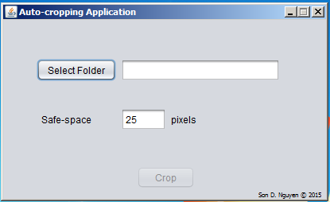

3. Choose “Select Folder” and select one folder that have uncropped maps. And click “Open”.

4. Click “Crop” and the application will display the message “Cropping Completed!” after a few minutes. 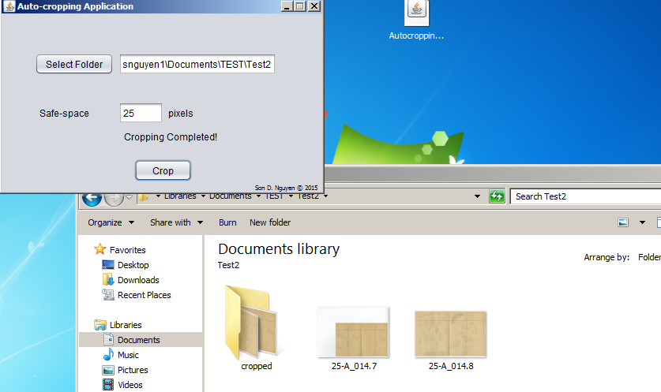

5. All the cropped maps are stored in the “cropped” folder inside the selected folder.

6. Go to “cropped” folder and check whether the maps are cropped correctly or not.

7. If a map was not cropped correctly, delete the cropped image and crop the image manually with Microsoft Office Picture Manager. The cropped image will always be saved in the “cropped” folder.

\*Note:

+ ImageMagick software and Java Runtime Environment (JRE) are needed to run this application.

+ Autocropping, ImageMagick & JRE can be downloaded at “Utilities” in JobFolder homepage.